Name _ Period_
A Cell compared to a City
Directions: Place the city below into Paint and then match the cell part with their jobs in the city (COPY INTO PAINT)
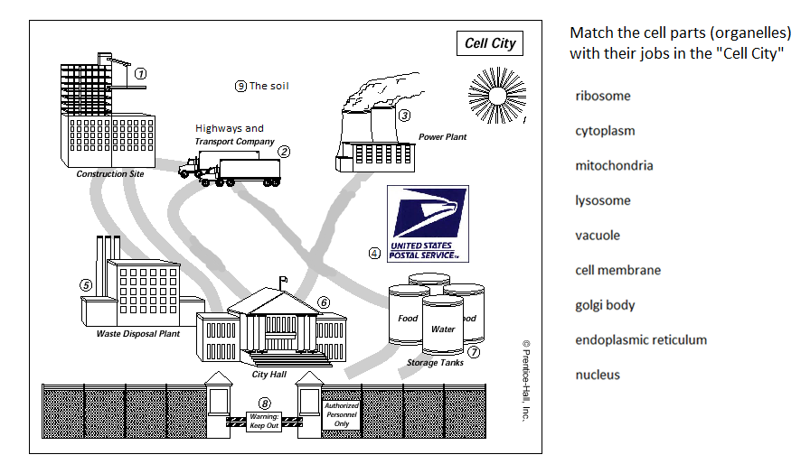
Answer these Essential Questions: (then print one page to turn in)
Why do the different organelles (cell parts) look different from each other?
What are the 3 main ideas to cell theory?
What are 5 things you learned or reviewed about cells?
How are the golgi body, ER, and ribosomes all related to one another?

