Cell (Animal or Plant) Comparison Project

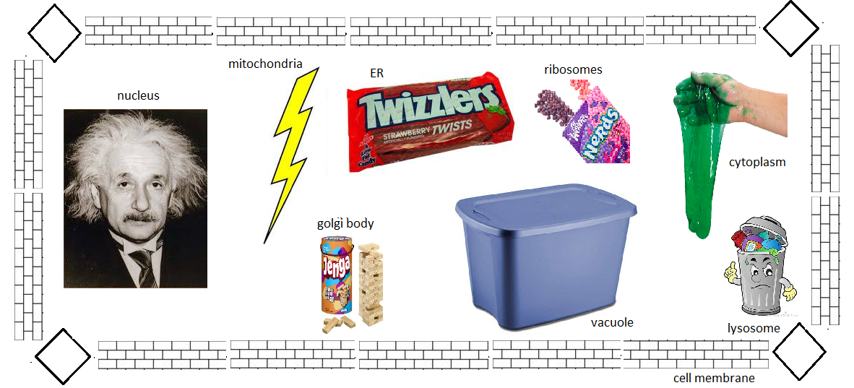

Checklist Key:

____ Nucleus - “the brain of the cell”
____ Golgi body -
____ mitochondria -
____ ER (endoplasmic reticulum) -
____ ribosome -
____ cytoplasm -
____ lysosome -
____ vacuole -
____ cell membrane -

