Name ______________________________ Period ________ | Name ______________________________ Period ________

Fossils, Earth’s Layers and Geologic Time | Fossils, Earth’s Layers and Geologic Time
PERIODS Quaternary Tertiary Cretaceous Jurassic Triassic Permian Carboniferous Devonian Silurian Ordovician Cambrian 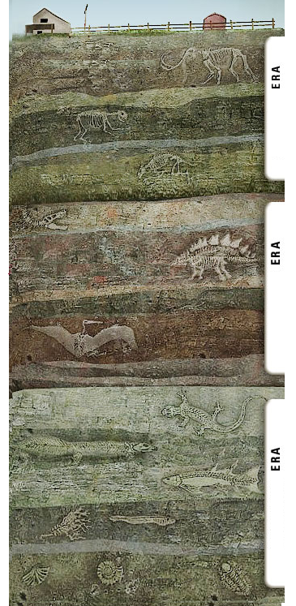 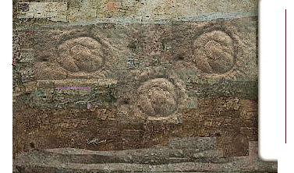  1. Label the 4 Eras  2. Label the correct dates for the Eras and Periods.  3. Correctly Label the following fossils: T-Rex, jellyfish, cockroaches,  first birds, people, trilobites, Dimetrodon, first dinosaurs, sharks, horses, arachnids, first birds, bacteria, amphibians, elephants, first insects,  first flowers, dinosaur extinction, Pangaea forms | 1. Label the 4 Eras.  PERIODS  Quaternary  Tertiary  Cretaceous  Jurassic  Triassic  Permian  Carboniferous  Devonian  Silurian  Ordovician  Cambrian  2. Label the correct dates for the Eras and Periods.  3. Correctly Label the following fossils: T-Rex, jellyfish, cockroaches,  first birds, people, trilobites, Dimetrodon, first dinosaurs, sharks, horses,  arachnids, first birds, bacteria, amphibians, elephants, first insects,  first flowers, dinosaur extinction, Pangaea forms
The Geologic Time Scale  Understanding Main Ideas  Put the following items in order from oldest (1) to most recent (4)  by writing a number in the blank beside each.  _________ 1. Mesozoic Era _________ 3. Cenozoic Era  _________ 2. Precambrian Time _________ 4. Paleozoic Era  Rewrite the following sentence to make it true.  5. Geologists subdivide periods into eras.  _________________________________________________________  ___________________________________________________________  6. Why is the geologic time scale used to show Earth’s history?  7. What methods did geologists use when they first developed the geologic  time scale?  8. What events end the Eras?  9. Geologists divide the time between Precambrian Time and the present  into three long units of time called ________________________.  10. The record of life forms and geologic events in Earth’s history is called the ________________________________________ .  11. Place the following in the correct order from earliest to latest:  ___ Tertiary,___ Jurassic, ___ Quaternary, ___ Triassic, ___ Cretaceous  12. Look at Figure 14. Which Era lasted the longest? | The Geologic Time Scale  Understanding Main Ideas  Put the following items in order from oldest (1) to most recent (4)  by writing a number in the blank beside each.  _________ 1. Mesozoic Era _________ 3. Cenozoic Era  _________ 2. Precambrian Time _________ 4. Paleozoic Era  Rewrite the following sentence to make it true.  5. Geologists subdivide periods into eras.  ____________________________________________________________________________________________________________________  6. Why is the geologic time scale used to show Earth’s history?  7. What methods did geologists use when they first developed the geologic time scale?  8. What events end the Eras?  9. Geologists divide the time between Precambrian Time and the present  into three long units of time called ________________________.  10. The record of life forms and geologic events in Earth’s history is called the ________________________________________ .  11. Place the following in the correct order from earliest to latest:  ___ Tertiary,___ Jurassic, ___ Quaternary, ___ Triassic, ___ Cretaceous  12. Look at Figure 14. Which Era lasted the longest?

