“How Do I Print?” Follow these directions in order

STEP 1:

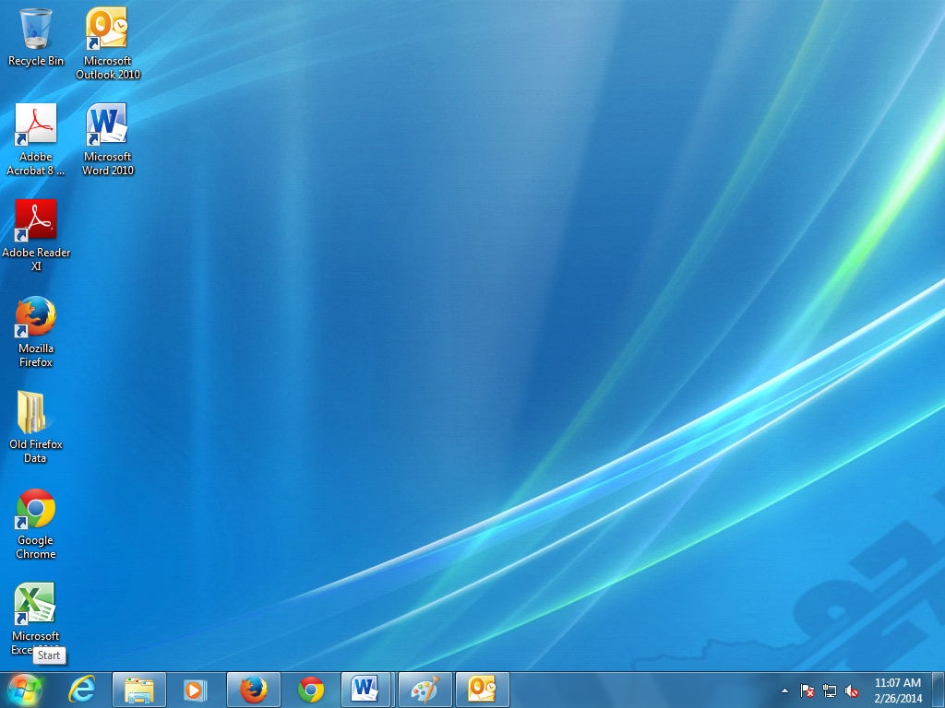

Click Here First

STEP 2:

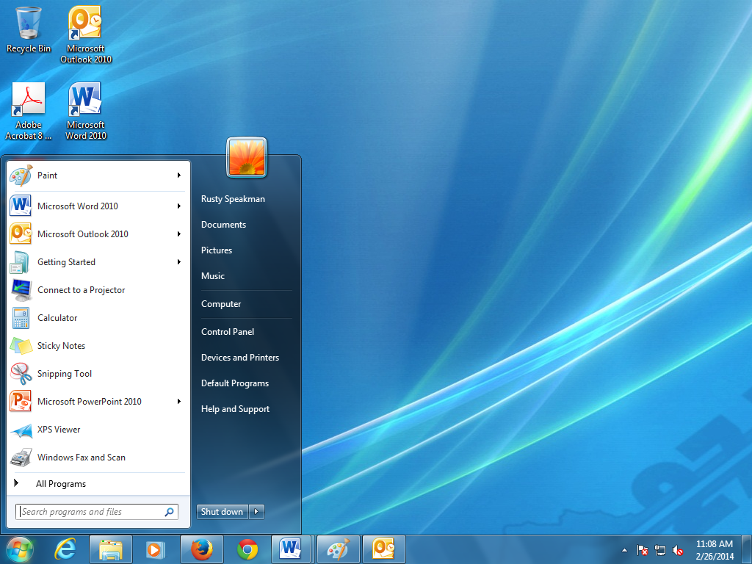

Click Devices and Printers Next

STEP 3:

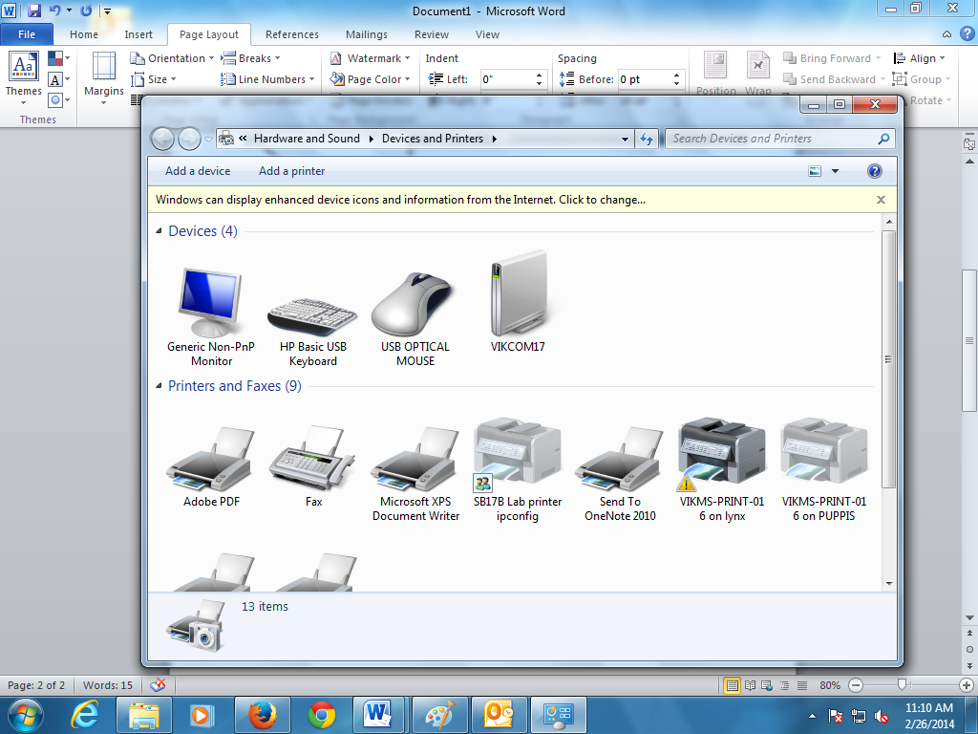

Click Add a Printer

STEP 4:

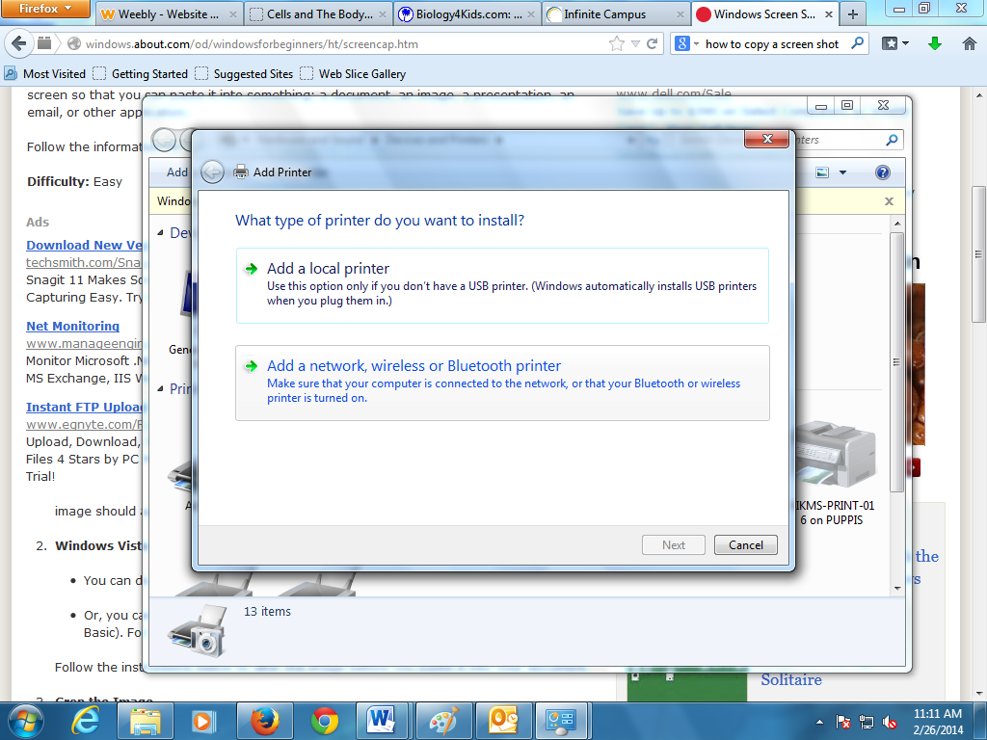

Click **Add a network…**

STEP 5:

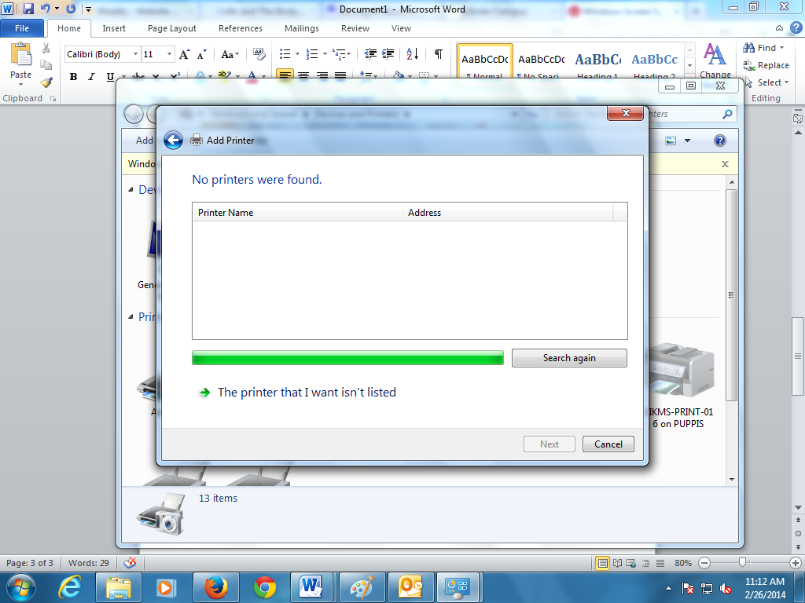

Click **The Printer that I want...** Next

STEP 6:

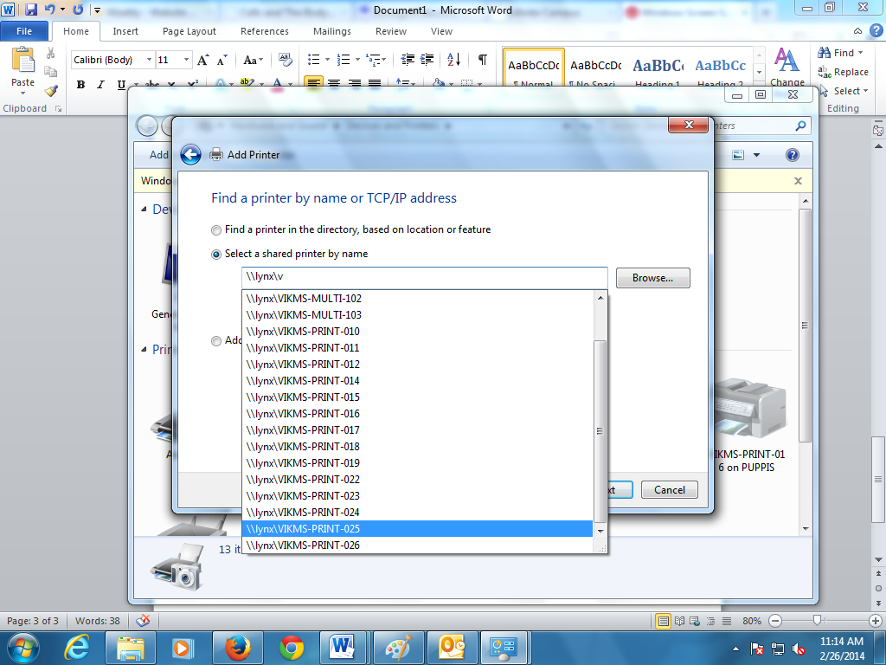

In the box type exactly: \\lynx\v

and then select the Printer you want

STEP 7:

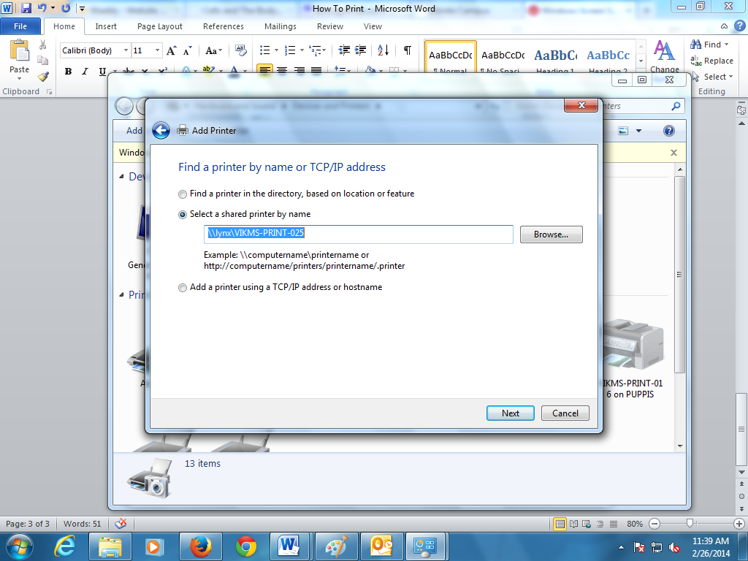

Click **Next and then Finish**

STEP 8: PRINT!!!